

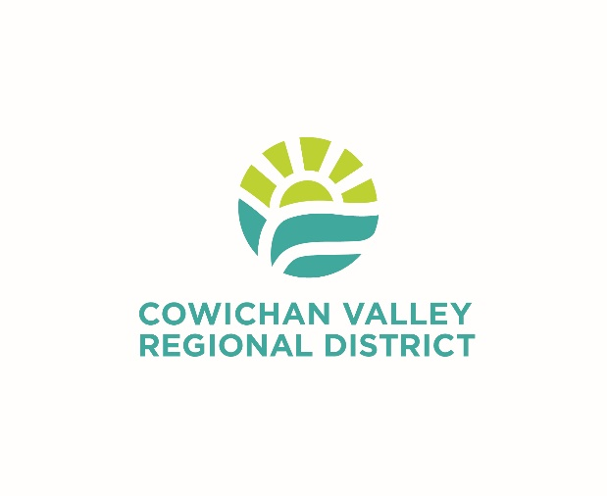
Application Deadline: September 9, 2026, at 4:30 pm
Applications: Qualified applicants are invited to apply online at careers-cvrd.icims.com
Competition Number: 26160-E
Located on Vancouver Island just 50 km north of Victoria and 30 km south of Nanaimo, the Cowichan Valley Regional District (CVRD) is in the ancestral and unceded territories of First Nations including the Quw'utsun, Malahat, Ts'uubaa-asatx, Halalt, Penelakut, Stz'uminus, Lyackson, Pauquachin, Ditidaht, and Pacheedaht Nations. Local First Nations Peoples have stewarded the lands, waters, plants, and animals of this region since beyond time immemorial. The CVRD provides a wide range of local government services to a population of 95,000. The picturesque Cowichan Valley offers a warm climate and numerous parks, recreational, cultural, and social opportunities such as majestic mountains, the rugged West Coast Trail, serene lakes, and one of the world’s tallest free-standing timber rail trestles.
The Opportunity:
Join the CVRD as our Planning Coordinator and play a key leadership role in guiding planning services, mentoring staff, coordinating major development initiatives, and helping build vibrant, sustainable communities.
The immediate need is for a Planning Coordinator in the Development Services Division, supporting customer service and development applications processes.
Our Ideal Candidate:
- University graduation in a related field plus a graduate degree in Community and Regional Planning or related field
- Full membership in the Canadian Institute of Planners and Planning Institute of BC Registered Professional Planner Certification
- A minimum of five years of related experience, preferably in a BC local government setting
- A minimum of two (2) years of experience with staff mentoring, supervision, training and performance management
- IAP2 certification is considered an asset
- PMP designation is considered an asset
- A valid Class 5 BC Driver's Licence
- An equivalent combination of education, training, and experience may be considered
Please see the job description at careers-cvrd.icims.com for the full job details and qualifications.
What We Offer:
- Salary range of $111,765.09 to $130,660.09 per year, commensurate with education, training and experience
- Comprehensive benefits package including extended health, dental, and insurance benefits, pension, and paid vacation
- 35-hour full-time work week with the opportunity to participate in the CVRD’s Flex Time and Work-From Home Programs.
- To Apply:
If you are collaborative and forward-thinking and enjoy supporting a talented team, leading planning operations and helping to deliver innovative land use and community planning initiatives that make a lasting impact, then submit your cover letter and resume in confidence at the application link below by the date indicated.
We thank all applicants for their interest. Only shortlisted applicants will be contacted. If you require an accommodation to participate in any stage of the hiring process please contact Human Resources at hr@cvrd.bc.ca to communicate your accommodation needs. Please include the position title and competition number.
Planning Coordinator (Exempt Position)
Development Services Division
Land Use Services Department
Cowichan Valley Regional District

Live where you work
Cowichan Valley Regional District | 175 Ingram Street, DUNCAN BC V9L 1N8 | Phone: 250.746.2500 Fax: 250.746.2522 | www.cvrd.ca

